Hotel Rwanda Viewing Guide
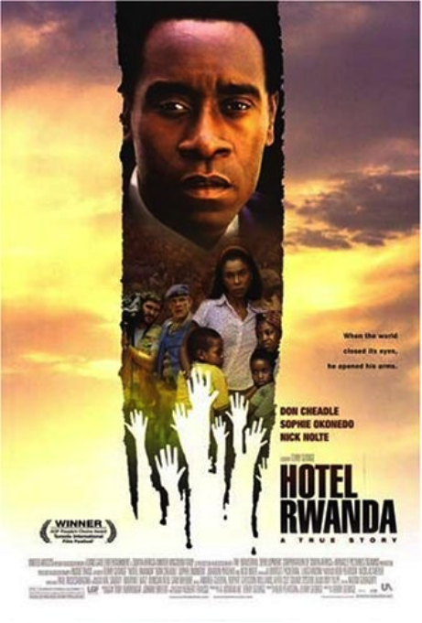
Helpful Info:
The movie is set in Kigali, the capital city of Rwanda

Main Characters: Paul Rusesabagina & his wife Tatiana
Paul is the assistant manager of the hotel Mille Collines, which is owned by a Belgian company named Sabena. Paul is a Hutu, and Tatiana is a Tutsi.

The UN is visiting Rwanda as the president is signing a peace agreement with the Tutsis.
The UN soldiers will be wearing light blue vests & hats.

The Hutu soldiers (called the Interahamwe) will be wearing colorful uniforms.

The police & military of Rwanda will be wearing regular camouflage uniforms.

Answer these questions before watching:
- What is a refugee? A refugee is somebody who is forced to leave their country to escape conflict in their own nation.

- What is genocide? Genocide is deliberately killing a huge number from an ethnic group or nation.

- What other famous event was going in on Africa in 1994? This was the first election after the apartheid was removed from their system. Nelson Mandela becomes the president.

Answer these questions while watching:
- Why does the country of Rwanda use francs as their currency? Rwanda uses francs as their currency since Belgium took over the last German colony.

- When Paul’s neighbor (Victor) gets attacked, what does Paul do? Why? When Victor gets attacked, Paul doesn’t do anything since Victor isn’t family. Family is all that matters according to Paul, and he doesn’t want to risk the consequences.

- What was the significance of the phrase “cut the tall trees?” The phrase, “Cut the tall trees” is meant to represent how the Tutsis were taller than the average Hutu. It just means to go to war and kill the Tutsis.

- When violence breaks out, who comes to help? Who gets helped? Who doesn’t get helped? When violence breaks out, The United Nations comes to help. They helped the whites but did not help the Rwandan people.

- When Paul realizes no one is coming to help the Rwandan refugees, he tells them there is only one way for them to get help. What is it? When Paul realizes that no one is coming to help the Rwandan refugees, he suggests calling all of your friends and family. Then you will guilt them into sending help, and this prevents deaths since people are helping out.

- What deal does George try to make with Paul? The deal George tries to make with Paul is that he will be called a criminal and used. If he helps him leave, then he’ll help him escape jail time.

Answer these questions after watching:
- Why didn’t any foreign countries try to stop the Hutus? Other countries chose not to get involved because they didn’t have enough resources to stop the Hutus.

- What event sparked the beginning of the genocide? Who does that event get blamed on? The genocide was sparked by the death of the Rwandan President, who was a Hutu.

- Who was supplying the Hutu army? The Hutu army was being supplied by the French.

- What did 19th century imperialism have to do with this 20th century genocide? In the 19th century, conflicts due to imperialism led to tension between the Hutus and Tutsis.

Closing Questions:
- Where did the classifications of Hutu and Tutsi come from in Rwanda? The classifications of Hutu and Tutsi in Rwanda were based on your wealth. If you owned livestock, you were a Tutsi, and if you didn’t, you were known as a Hutu.

- Why are some people being helped and others are not? This is because people are suspicious of others. Some people may be rebels and don’t know who to trust.

- If you were in Paul’s position, do you think your reaction would have been the same as his? Explain. No, since he took many risks saving people and made everyone’s lives better.

- How did the international community fail the people of Rwanda? Why were they so reluctant to act? What is our responsibility as global citizens in these kinds of events? How are events in Rwanda and Darfur connected to 19th century imperialism? The international community failed the people of Rwanda since they failed to prevent and stopped the Rwandan genocide. They were reluctant to act since they didn’t think much of it. Our responsibility as global citizens are to help stop genocides or any major mass killings from happening. The events in Rwanda and Darfur are connected to 19th century imperialism because previous conflicts led to up the genocides.

- What are some historical inaccuracies of this film? Survivors from the hotel claims that the manager made them pay for everything,

